**Instruction Manual-DM542**

**Stepper Motor Driver**

1、 Introduction

This stepper motor driver is a professional two-phase driver, it can realize the motor positive or inversion control. The S1,S2,S3 dial switchs’ function is corresponding to 8-ch current control (1.0A, 1.46A, 1.91A, 2.37A, 2.84A, 3.31A, 3.76A and 4.20A). The S4 dial switch’s fuction is choosing the half current or full current . The S5,S6,S7,S8 dial switchs’ function is corresponding to 15 subdivision control (2, 4, 8,16,32,64,128,5,10,20,25,40,50,100,125).It’s suitable for driving 86(<4NM),60,57,42 (two phase or four phase hybrid) stepper motors. The driver has the characteristics of low noise, small vibration and stable operation.The CPU of the driver is digital MCU.

Electrical parameters:

|  |  |
| --- | --- |
| Input voltage | 12～50VDC |
| Input current | 1.0～4.2A |
| Output current | 1.0～4.2A |
| Maximum power | 200W |
| Subdivision | 2, 4, 8,16,32,64,128,5,10,20,25,40,50,100,125 |
| Temperature | -10～55℃； storage temperature,-20℃～65℃ |
| Humidity | not dew, not water |
| Gas | combustible gas and electricity are forbidden |
| Weight | 0.25kg |

2、Input and output instructions

The signal input terminal

（1）PUL+: pulse signal input positive

（2）PUL-: pulse signal input negative

（3）DIR+: direction control input positive

（4）DIR-: direction control input negative

（5）EN+: Motor free control positive

（6）EN-: Motor free control negative

The motor winding connection

（1）A+: connecting the motor winding A+ phase

（2）A-: connecting the motor winding A- phase

（3）B+: connecting the motor winding B+ phase

（4）B-: connecting the motor winding B- phase

The voltage of power supply connection(12 -50VDC)

（1）DC-: power positive "+"

（2）DC+: power negative "-".

3、Dimensions and Appearance

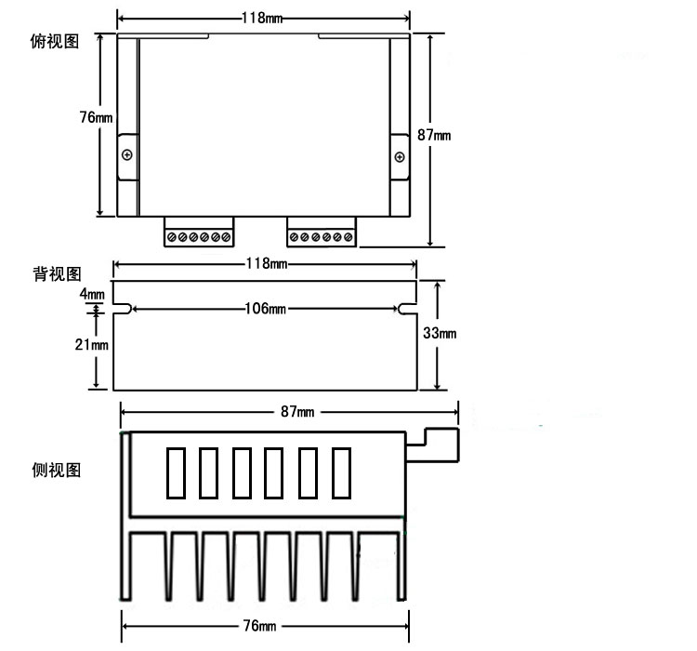

1. Subdivision and current setting by the code switchs

Attention: the dial switch is pressed down: ON.

(1) Current: setting by the S1,S2,S63

|  |  |  |  |
| --- | --- | --- | --- |
| **CUR** | **S1** | **S2** | **S3** |
| **1.0A** | **ON** | **ON** | **ON** |
| **1.46A** | **OFF** | **ON** | **ON** |
| **191A** | **ON** | **OFF** | **OFF** |
| **2.37A** | **OFF** | **OFF** | **ON** |
| **2.84A** | **ON** | **ON** | **OFF** |
| **3.31A** | **OFF** | **ON** | **OFF** |
| **3.76A** | **ON** | **OFF** | **OFF** |
| **4.20A** | **OFF** | **OFF** | **OFF** |

(2)The S4

|  |  |
| --- | --- |
| **S4** | **Current** |
| **ON** | **Full Current** |
| **OFF** | **Half Current** |

1. Subdivision: setting by the S5,S6,S7,S8.

|  |  |  |  |  |
| --- | --- | --- | --- | --- |
| **SUB/Pulse per circle** | **S5** | **S6** | **S7** | **S8** |
| **2** | **OFF** | **ON** | **ON** | **ON** |
| **4** | **ON** | **OFF** | **ON** | **OFF** |
| **8** | **OFF** | **OFF** | **ON** | **ON** |
| **16** | **ON** | **ON** | **OFF** | **ON** |
| **32** | **OFF** | **ON** | **OFF** | **ON** |
| **64** | **ON** | **OFF** | **OFF** | **ON** |
| **128** | **OFF** | **OFF** | **OFF** | **ON** |
| **5** | **ON** | **ON** | **ON** | **OFF** |
| **10** | **OFF** | **ON** | **ON** | **OFF** |
| **20** | **ON** | **OFF** | **ON** | **OFF** |
| **25** | **OFF** | **OFF** | **ON** | **OFF** |
| **40** | **ON** | **ON** | **OFF** | **OFF** |
| **50** | **OFF** | **ON** | **OFF** | **OFF** |
| **100** | **ON** | **OFF** | **OFF** | **OFF** |
| **125** | **OFF** | **OFF** | **OFF** | **OFF** |

5、Input terminal connection (control signal)

Three input signals,First: steps connet to the pulse signal PUL+, PUL-; Second: the direction Signal connets to the DIR+, DIR-; Third: the freedom input signal connets to the EN+, EN-. The input signal interface has two kinds of connection method, The users can use the common anode or the common cathode method.

1. Common anode method

if the control system’s power voltage supply is 3V ~24V,the PUL+, DIR+, EN+

are connected to the power +, and the pulse input signal is connected with PUL- , and the direction signal is connected with the DIR-,and the free signal is connected with EN-.

(2)Common cathode method

The PUL-, DIR-, EN- are connected to the ground terminal of the control system; and the pulse input signal is connected with PUL+ , and the direction signal is connected with the DIR+,and the free signal is connected with EN+.

